USING FOR LOOP:

import numpy as np import cv2 square_size=50

# Create a blank white img

img=np.ones((8*square_size,8*square_size,3))*255 for i in range(8): for j in range(8): if (i + j)%2==1:

img[i*square_size:(i + 1)*square_size,j*square_size:(j + 1)*square_size]=[0,0,0]#black squares at concurrent areas cv2.imshow('Checker board Pattern',img) cv2.waitKey(0) cv2.destroyAllWindows()

OUTPUT:

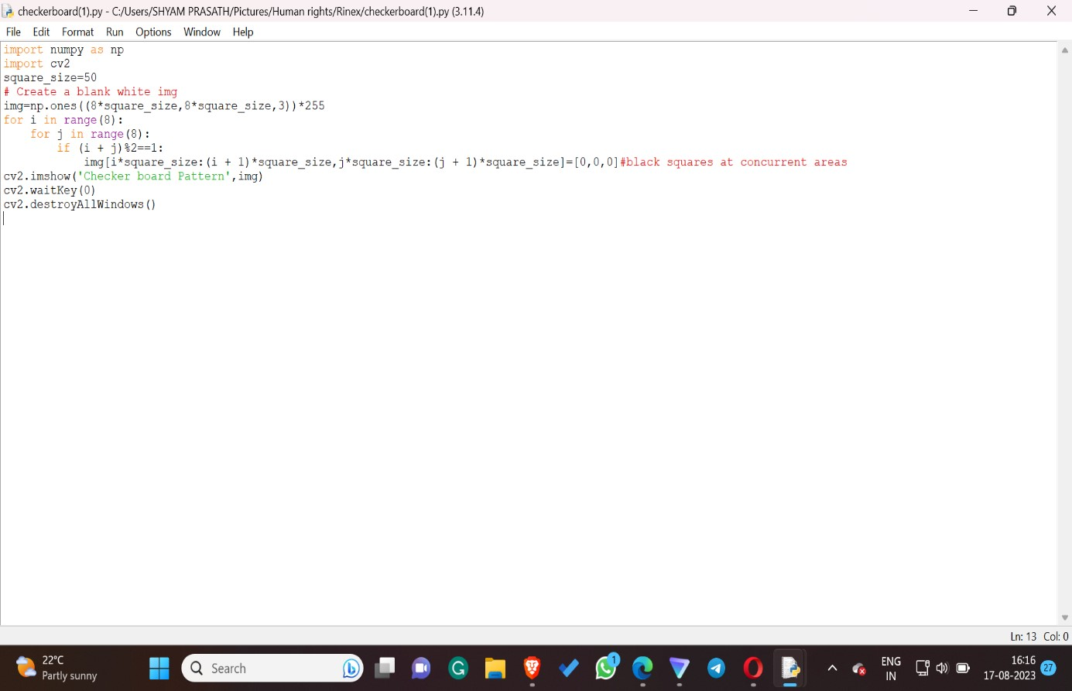

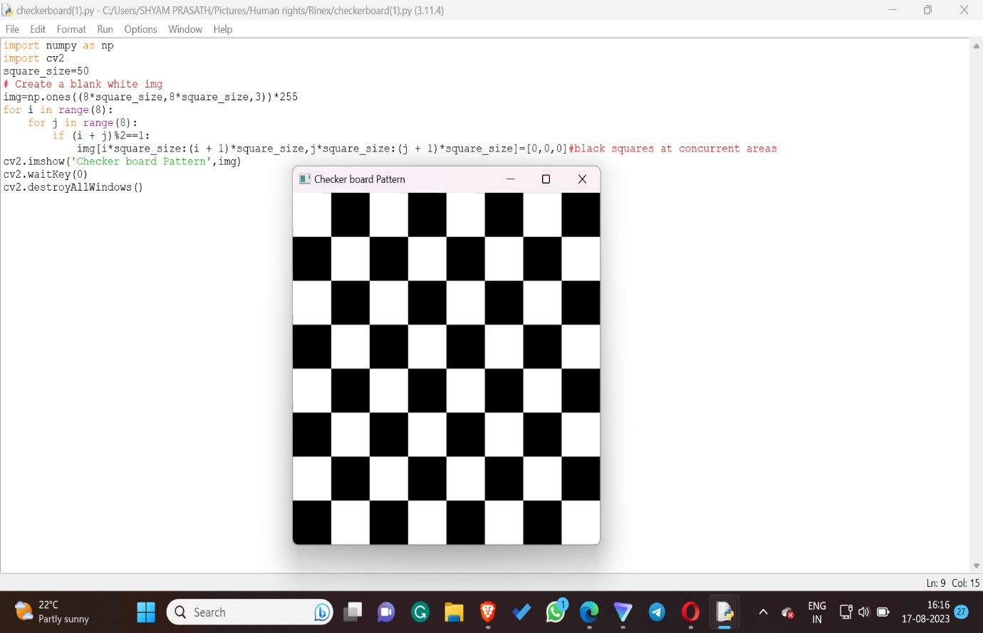

USING WHILE LOOP:

import numpy as np import cv2

square_size=50 #rough idea of square area

# Create a blank white canvas

img=np.ones((8*square_size,8*square_size,3))*255 i=0 while i<8:

j=0 while j<8: if (i+j)%2==1:

img[i*square_size:(i+1)*square_size,j*square_size:(j+1)*squa re_size]=[0,0,0]#black covering area j=j+1 i=i+1

cv2.imshow('Chessboard Pattern(8 x 8)',img) cv2.waitKey(0) cv2.destroyAllWindows()

OUTPUT:

